Training document for the company-wide
automation solution
Totally Integrated Automation (T I A)

MODULE A2
Installation of STEP 7 V5.x /
Authorization Process

This document was provided by Siemens A&D SCE (automation and drive technology, Siemens A&D Cooperates with Education) for training purposes. Siemens does not make any type of guarantee regarding its contents.

The passing on or duplication of this document, including the use and report of its contents, is only permitted within public and training facilities.

Exceptions require written permission by Siemens A&D SCE (Mr. Knust: E-Mail: michael.knust@hvr.siemens.de). Offences are subject to possible payment for damages caused. All rights are reserved for translation and any case of patenting or GM entry.

We thank the company Michael Dziallas Engineering and the instructors of vocational schools as well as further persons for the support with the production of the document.

PAGE:

1. Forward 4

2. Notes for the operation of STEP 7 V5.x 6

3. Installation of the Software STEP 7 V5.x 7

4. Handling of the Authorization 13

5. Upgrading of the Authorization 15

6. Program Interface Adjustment 19

The following symbols stand for the specified modules:


Information


Installation




Notes

1. Forward

The module A2 is assigned content wise to the Basics of STEP 7- Programming.

Basics of

STEP 7- Programming
2 - 3 days A modules

Additional functions of
STEP 7- Programming
2- 3 days B modules

Industrial field bus
systems
2- 3 days D modules
Process
visualization
2- 3 days F modules
Sequencer
programming
2- 3 days C modules C

IT- Communication
with SIMATIC S7
1- 2 days E modules

Learning goal:

In this module, the reader should be shown how the software STEP 7 V 5.x is installed and how the interface for the SIMATIC S7-300 is set.

• Installation of the software
• Handling of the authorization
• Setting of the program interface

Requirements:

For the successful use of this module, the following knowledge is assumed:
• Knowledge in the use of Windows 95/98/2000/ME/NT4.0

Required hardware and software

1 PC, Operating system Windows 95/98/2000/ME/NT4.0 with
- Minimal: 133MHz and 64MB RAM, approx. 65 MB free hard disk space
- Optimal: 500MHz and 128MB RAM, approx. 65 MB free hard disk space
2 Software STEP 7 V 5.x
3 MPI- Interface for the PC (e.g. PC- Adapter)
4 PLC SIMATIC S7-300
Example configuration:
- Power supply: PS 307 2A
- CPU: CPU 314
- Digital inputs: DI 16x DC24V
- Digital outputs: DO 16x DC24V / 0.5 A

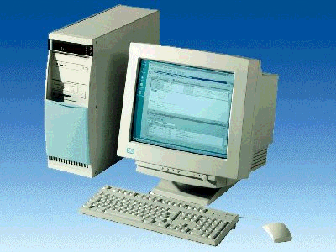
1 PC
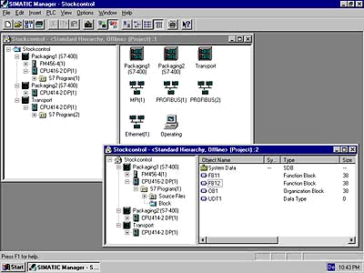
2 STEP 7

3 PC Adapter

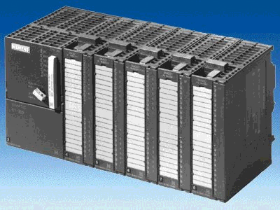
4 S7-300

2. Notes for the operation of STEP 7 V5.x
The software STEP 7 is the program tool for the automation systems
- SIMATIC S7-300
- SIMATIC S7-400
- SIMATIC WinAC
With STEP 7, the following functions can be used for the automation construction:
- Configuring and parameterization of hardware
- Programming
- Debug, commissioning, and service
- Documentation, archiving
- Operation-/Diagnostic functions
All functions are supported and described through elaborate online help documentation.

Also contained as options by STEP7 V 5.x:
- Acrobat Reader V3.01 in order to be able to read the provided handbooks.
- NCM S7 – PROFIBUS V5.1 incl SP3
- NCM S7 – Ind. Ethernet V5.1 incl SP3
- AuthorsW V2.2

3. Installation of the Software STEP 7 V 5.x
STEP 7 has three different versions:
- STEP 7 Professional version, which can use all applications provided by STEP 7(S7- GRAPH or S7- PLCSIM). This software package must be authorized.
- STEP 7 Software for Students contains the option package S7- PLCSIM. This software package must be authorized and then it can be used for 120 days.
- STEP 7 Mini is a restricted version that does not need to be authorized, however, no further option packages can be used (e.g. S7- PLCSIM or S7- GRAPH).

STEP 7 comes on a CD-ROM, which contains the software. With the CD-ROM comes a floppy disk, which contains the authorization of the software. After the data from this disk is transferred to the PC, STEP 7 professional version can be used by the operator.
This authorization disk can also be used on another PC or can be copied in order to authorize the software.

To install STEP 7, please proceed to the following steps.

1. Place the STEP 7 CD in the CD- ROM drive.

- The setup program should start automatically. If not, it can be started by double clicking on the setup.exe executable file on the CD. The setup program will guide you through the whole installation process of the STEP 7 software.

- In order to use the professional version of STEP 7, the software must be authorized on your computer. The files from the authorization disk must be transferred onto the PC.
This process will execute at the end of the software installation. If you place the authorization disk in the floppy drive at the beginning of the installation, the authorization will automatically transfer onto your computer.
Place the authorization diskette in the floppy drive now during the setup start.

4. When setup runs, you are first asked in which language to continue setup in. Choose the desired language and accept it Next ( → Next).

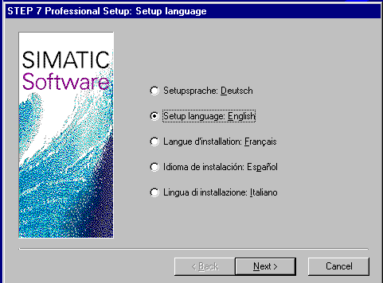

5. After language selection, the optional software packages are chosen. For the execution of all modules of this training document, the option NCM S7-PROFIBUS is needed ( → Next).

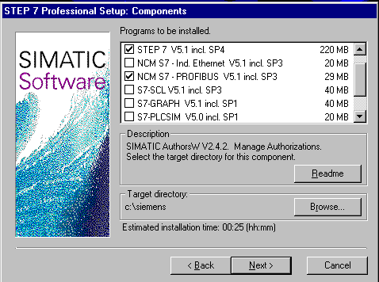

6. Then a window is displayed, that shows you which of the desired components is being currently installed. The installation can be Aborted if necessary ( → Abort).

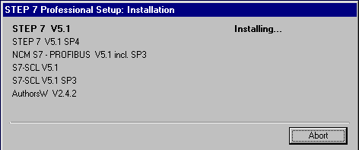

7. Finally you come to the first page of the STEP 7- Setup with a warning about copyright( → Next).

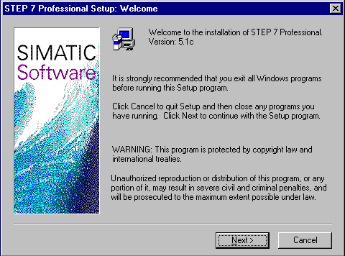

8. Now you can see the Readme if desired ( → Next).

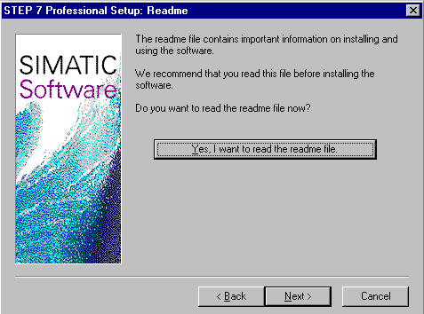

9. The Hard- and Software requirements are given in the following window. You can find Internet Explorer V4.01 SP1 on the included STEP 7 CD in case it is needed ( → Next).

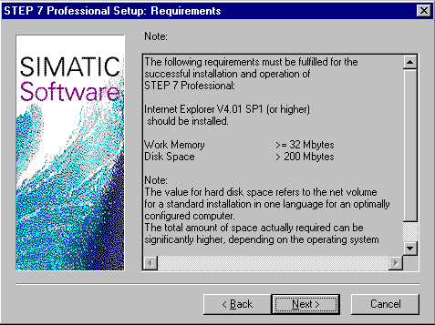

10. Now read the license agreement and accept it with Yes ( → Yes).

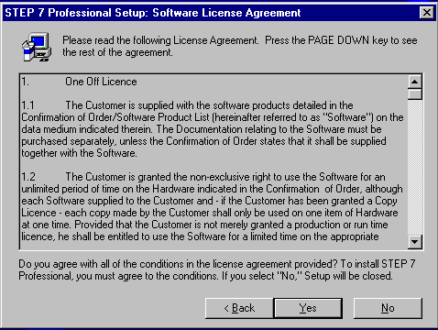

11. You must register and enter the ID number of your software license. You can find the ID number on the included software certificate. This number begins with ID: KHE... (→ Name → Company → Identnr. ID: KHE → Next).

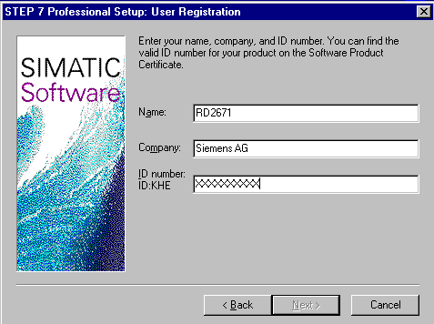

12. Here the target folder on the desired hard disk partition is chosen ( → Next).

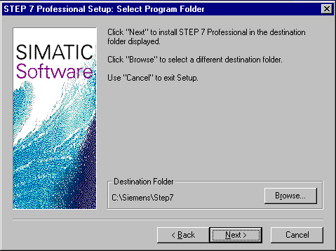

13. The Standard setup type is recommended because it is the least costly and is also installed with examples ( → Next).

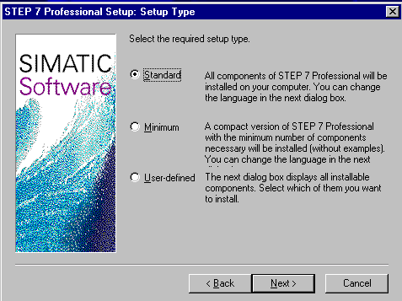

14. Now you can choose the installation languages to be installed ( → Next).

15. The installation is now started. One can see all the options expanded on the screen ( → Next).

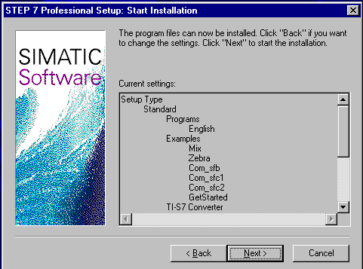

4. Handling of the authorization
The professional version of STEP 7 requires authorization that must be transferred onto the PC in order to make the use of the professional of STEP 7 possible.
In order to be used on another PC, the authorization can be returned to the disk when needed.

This happens as follows:

1. First the authorization disk must be placed in the disk drive and then the tool AuthorsW opened
(→ START → Simatic → AuthorsW → AuthorsW).

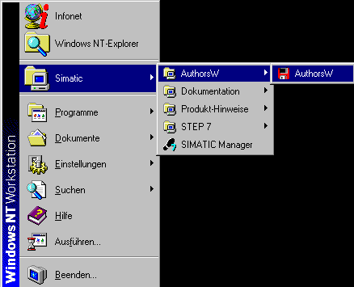

- Then the AuthorsW tool is opened and the hard disk as well as the disk are searched for authorizations.

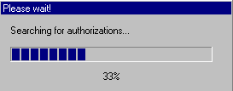

- In order to transfer the authorization, highlight the desired authorization with a mouse click and then transfer onto the disk with the button ←( → SIK/SIMATIC STEP 7-Basis V5.0 → ←).

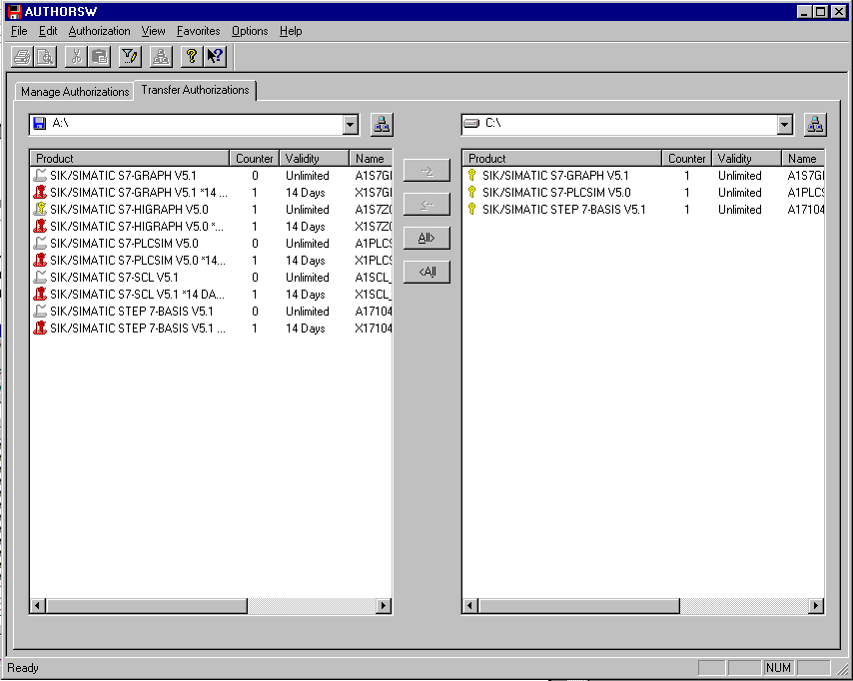

Note: Likewise one proceeds to transfer authorizations from the authorization disk to the hard disk.

5. UPGRADE of the authorization
When an older version of STEP 7 needs to be updated, there is the possibility to purchase a price efficient Upgrade. Before this can be installed, the authorization from your old authorization disk must be transferred to the new disk and then upgraded to the new version.
The requirement is that the authorization from the PC was transferred onto the old disk.

It is explained in the following, how version 4.x is upgraded to version 5.x.

1. First the update-authorization disk must be placed in the disk drive and the tool AuthorsW opened (→ START → Simatic → AuthorsW → AuthorsW).

2. Then the AuthorsW tool is opened and the hard disk as well as the disk are searched for authorizations.

3. The available authorizations on the disk and hard disk are displayed. On the disk, you can find the upgrade-license.

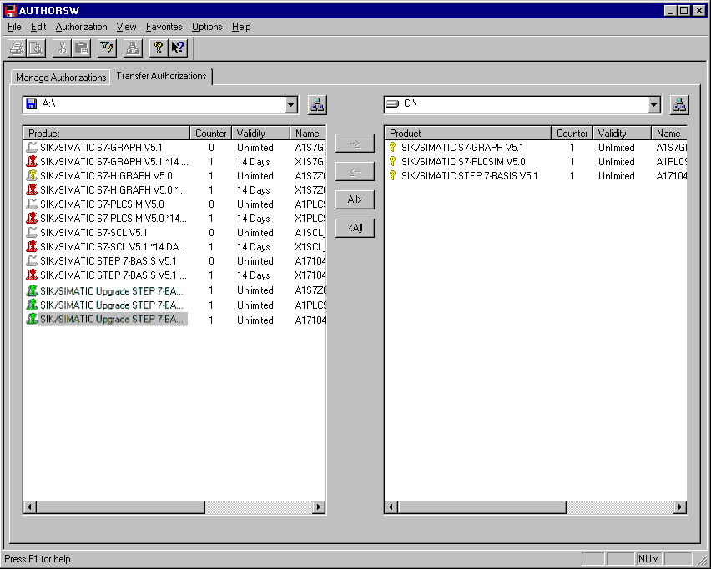

4. First the Upgrade of the Authorization is started ( → Authorization → Upgrade).

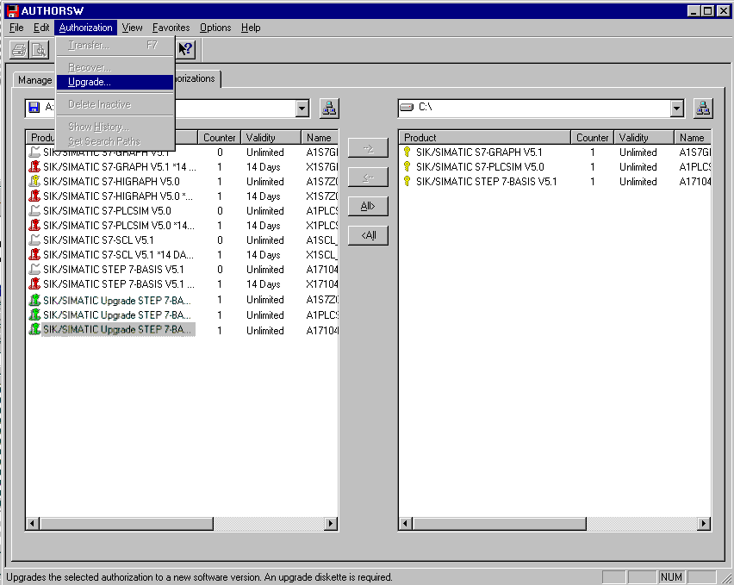

5. The displayed warning is accepted with OK (→ OK).

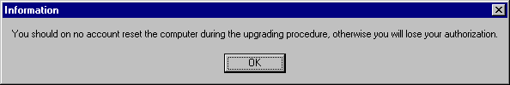

- Then choose from which authorization version you want to update
(→ Upgrade STEP 7- Basis V4.x-V5.1 → Open)

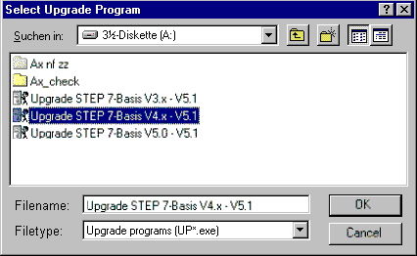

7. Now the authorization disk with the authorization for V4.x must be inserted and accepted with OK (→ OK).

8. It is then restated if the upgrade should be processed because the activity can no longer be canceled when started (→ OK).

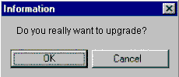

9. The update-authorization disk must be placed in the disk drive and the activity accepted with OK (→ OK).

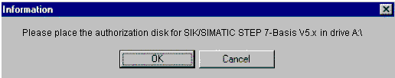

10. Finally it is displayed, that the upgrade was successful (→ OK).

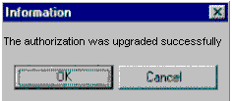

11. At the end of the process, the V5.1- License is displayed on the update- authorization disk.

6. Program interface adjustment (PC- Adapter)
In order to program a SIMATIC S7-300 from the PC or PG, an MPI-Connection is needed. MPI stands for Multi Point Interface and is a communication interface that has connections for up to 32 devices(e.g. PCs,HMI systems, etc.). It is used with HMI (Human Machine Interface) systems to program, serve and observe data exchange between SIMATIC S7 CPUs.

Each SIMATIC S7-300 possesses an integrated interface.

There are many possible ways to attach a PC or laptop to an MPI:
- Integrated ISA- Communication processors for the PG
- ISA- Communication processors for the PC (e.g. MPI-ISA- Card)
- PCI- Communication processors for the PC (e.g. CP5611)
- PCMCIA- Communication processors for the laptop (e.g. CP5511)
- Adapter for the communication over the serial interface of a PC or laptop (e.g. PC-Adapter)

The following steps below describe the calibration and parameters of a PC-Adapter for a PC.

1. Call Set PG-PC-Interface. ( → Start → SIMATIC → STEP 7 → Set PG-PC-Interface)

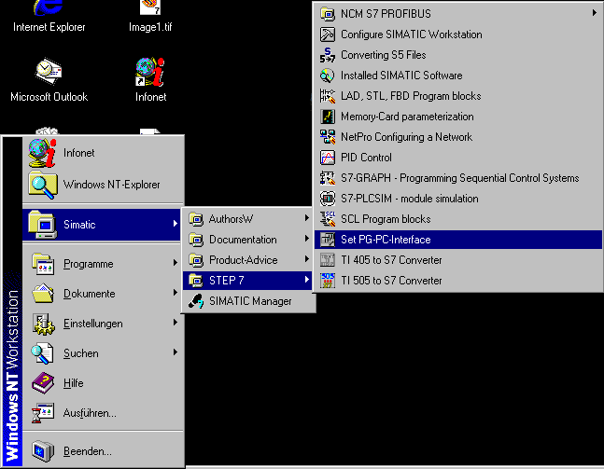
Click ‘Set PG-PC-Interface’!

2. The module Select is available as the MPI-interface ( → Select ).

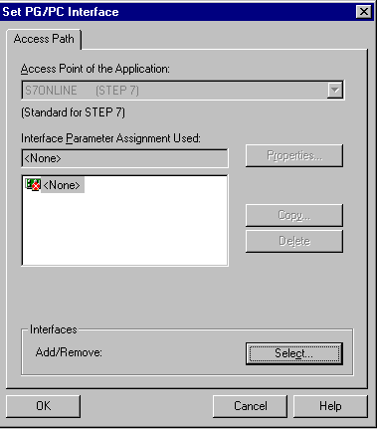
Choose ‘Select‘

3. Select the desired module e.g. choose PC-Adapter and Install (→ PC-Adapter →Install).


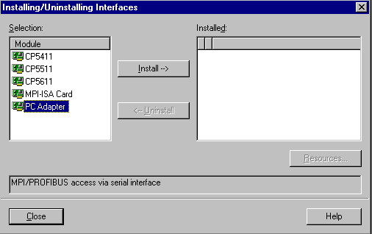
Choose ‘PC Adapter‘
Choose ‘Install‘

4. Make sure the desired module is present (→ PC Adapter → Close ).

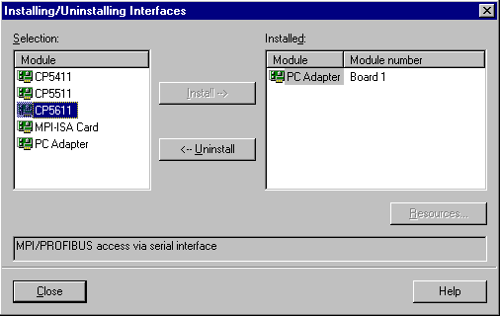
‘PC Adapter‘
Board 1
should be
present

5. Choose Properties of PC-Adapter (MPI) ( → PC Adapter(MPI) → Properties).

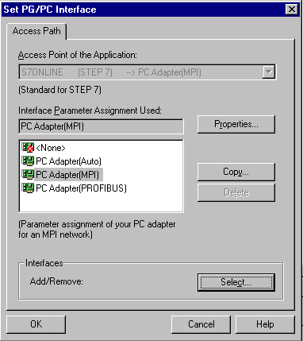
Choose ‘PC Adapter (MPI)’
Choose ‘Properties’

6. Set the COM-Port and the Transmission Rate of the serial interface.

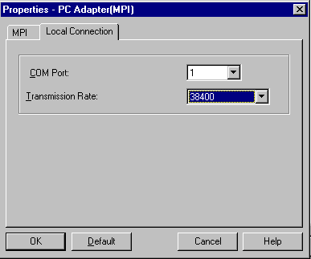
COM-Port
Transmission Rate

Note: The transmission rate must be suitably adjusted for the PC adapter! Older PC adapters (PC/MPI cables) should only be processed with a slower transmission rate of 19200 Bit/s .

- Set the MPI-Address, Timeout, Transmission Rate and Highest Node Address.

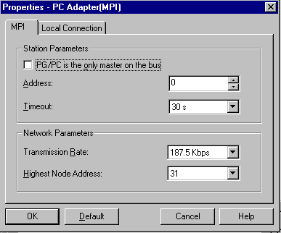
Transmission rate

Highest Node Address
Timeout
MPI-Address of the PC/PG

Note: It is recommended to use the preset values!

- Accept the configuration ( → OK → OK ).

9. After the values have been configured, double click on the SIMATIC Manager icon ( → SIMATIC Manager).
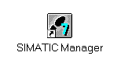
10. The plug placed from the MPI interface of the PC will appear on the MPI interface of the CPU and switch the voltage supply of the PLC on. The MPI interface is found behind the front flap of the CPU in the form of a 9pin D Sub socket.

11. When the button – Accessible Nodes is clicked and all parameters were correctly selected, the screen will display the following picture with a folder for the reached MPI interface. The MPI-Address of the CPU is also shown, which is calibrated with a 2 ( → ).

